**Guided Capstone Project Report**

The Big Mountain resort which currently charges $81 for a weekend ticket, has recently installed an additional chair lift. This additional chair increases their operating costs by $1,540,000 this season and this report aims to provide a better value for ticket price in order to compensate for increased operating costs.

The random forest model, when trained and fit on data of all resorts (except for Big Mountain resort), modelled the Big Mountain Resort price as $95.87which is $14.87 more than the actual price. The expected mean absolute error was $10.39 which suggests that price can be increased to somewhere between $85.48 to $95.87. Even considering the lower end of the range, the price can be increased by $4.48 to $85.48.

The increased operating costs of $1,540,000 for the current season due to additional chair lift, comes to $0.88 per ticket assuming the expected number of visitors this season to be 350,000 and skiing on average for 5 days. The price increase required to recover the additional operating costs is much less as compared to the suggested price increase.

There was little information on how important some of the Big Mountain facilities are as compared to others which hampers investment strategy. The model suggested the following most important features which are valued by visitors (in order of importance):

1. vertical_drop
2. Snow Making_ac
3. total_chairs
4. fastQuads
5. Runs
6. LongestRun_mi
7. trams
8. SkiableTerrain_ac

The Big Mountain resort performs reasonably well in each of these features. Here is the comparison for top 4 features:

|  |  |
| --- | --- |
| Most of the resorts have vertical drop of less than 1000 feet but Big Mountain resort does well with 2353 feet especially when vertical drop is most valued feature by visitors. | Big Mountain is among the top resorts in the list with 600 acres of snow making |
| Big Mountain is among the top resorts in the list with 14 chairs. | Most of the resorts have no Fast Quads and with Big Mountain having 3 of them, it is among the top 10% resorts. |

The options shortlisted by the business were also evaluated by the model to predict the ticket price:

1. As the below plot shows,closing 1 run makes no difference but 2 or 3 reduces support for ticket price by same amount as . Closing 10 runs reduces the support for ticket price by $1.75 per ticket. We can start by experimenting to close 1 run and increase it as per model outcome.

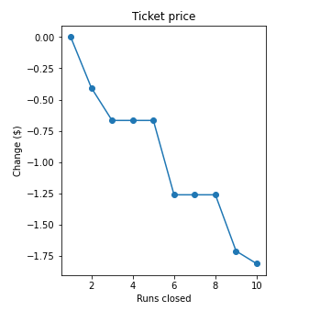

1. Increase the vertical drop by 150 feet lower down and installing an additional chair lift increases support for ticket price by $1.99. Assuming the number of visitors over coming season, it can translate into additional revenue of $3474638. It may be a good option to consider after taking into account the captial expenditure and additional operating costs for this option.
2. Adding 2 acres of snow making cover is too small to make any difference in support for ticket price.
3. Increase the longest run by 0.2 mile to and an additional snow making coverage of 4 acres does not make in difference in support for ticket price.